**Github Setup**

**Step-1:** create a new account in github.

* 1. Go to link : <https://github.com/> and enter username, email and password.

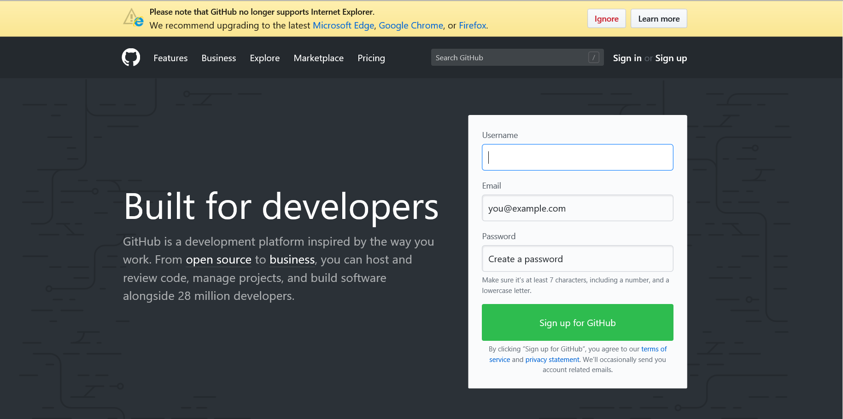

* 1. After giving username, email and password, click on “sign up for gitHub” Then go to your gmail account and verify it.

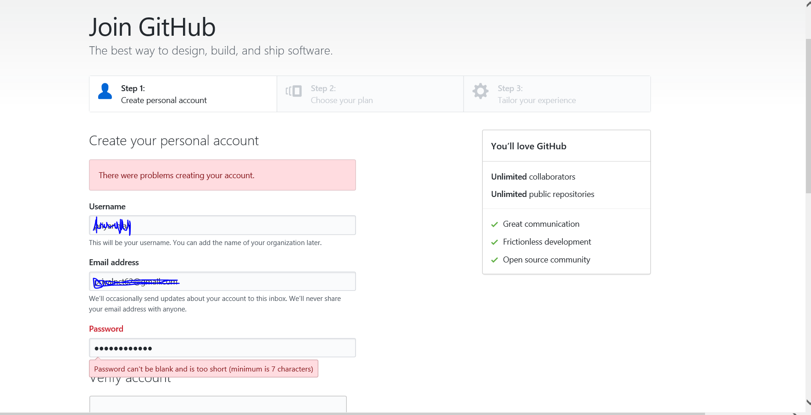

1.3: After verification click on “create an account”. Then choose your plan. And click on countnue.

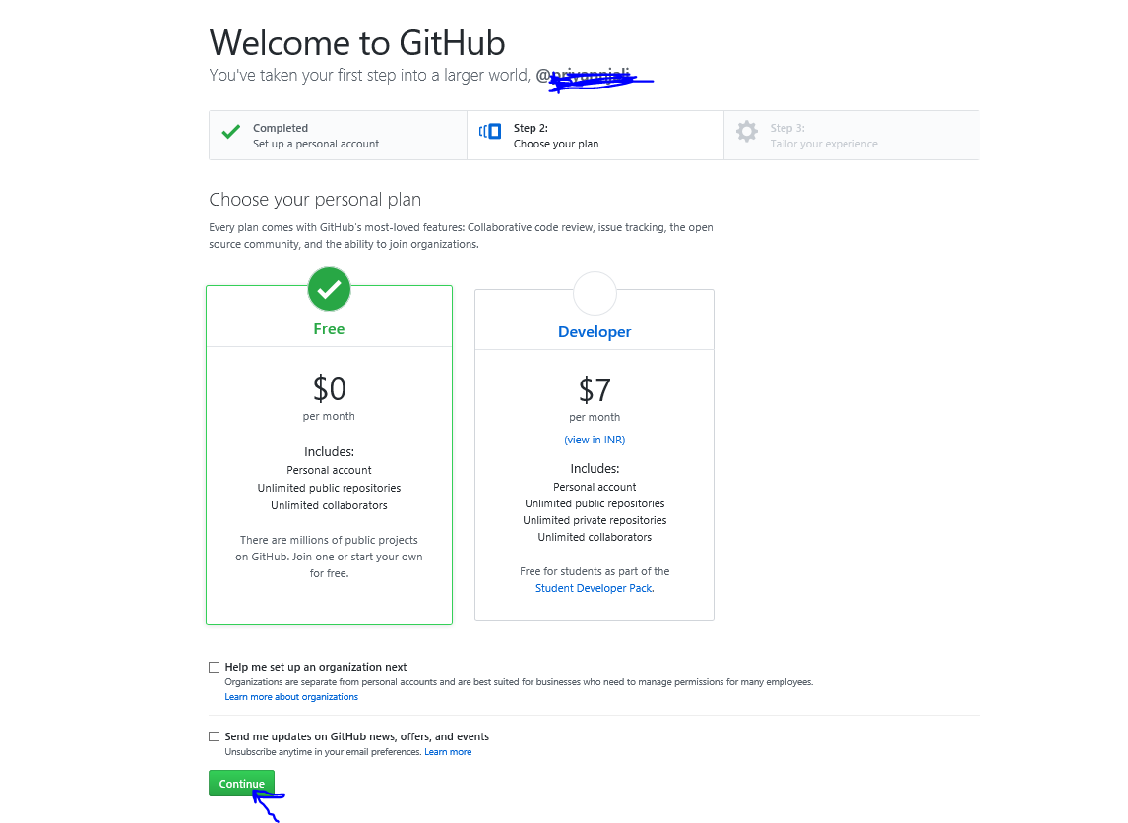

* 1. Then click on submit and you are ready to use github account.

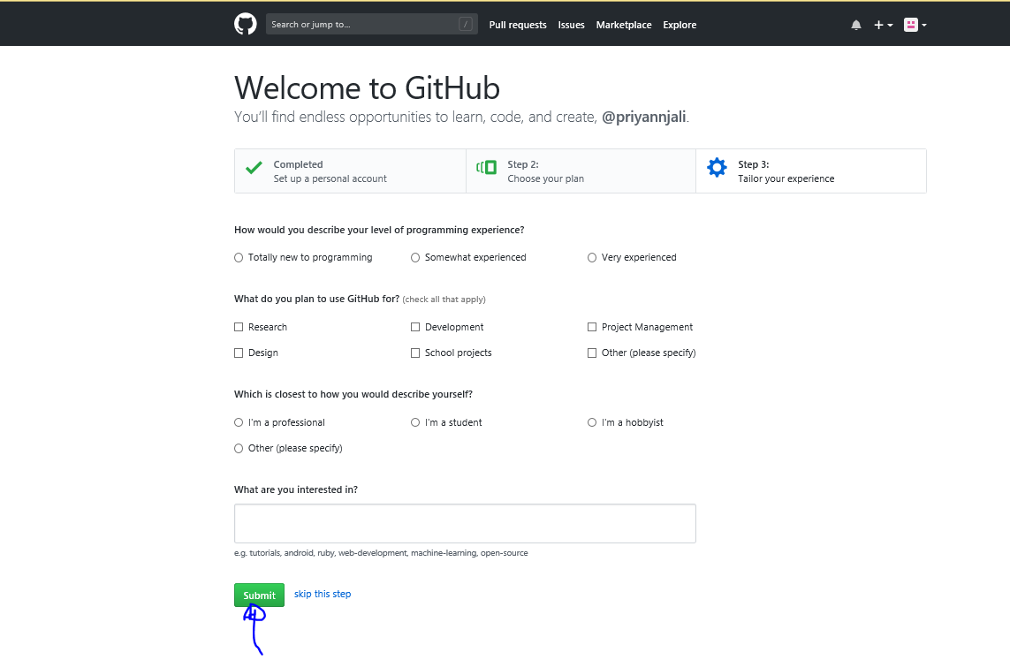

Step-2: Create Repository

* 1. Now click on “+” to create new repository

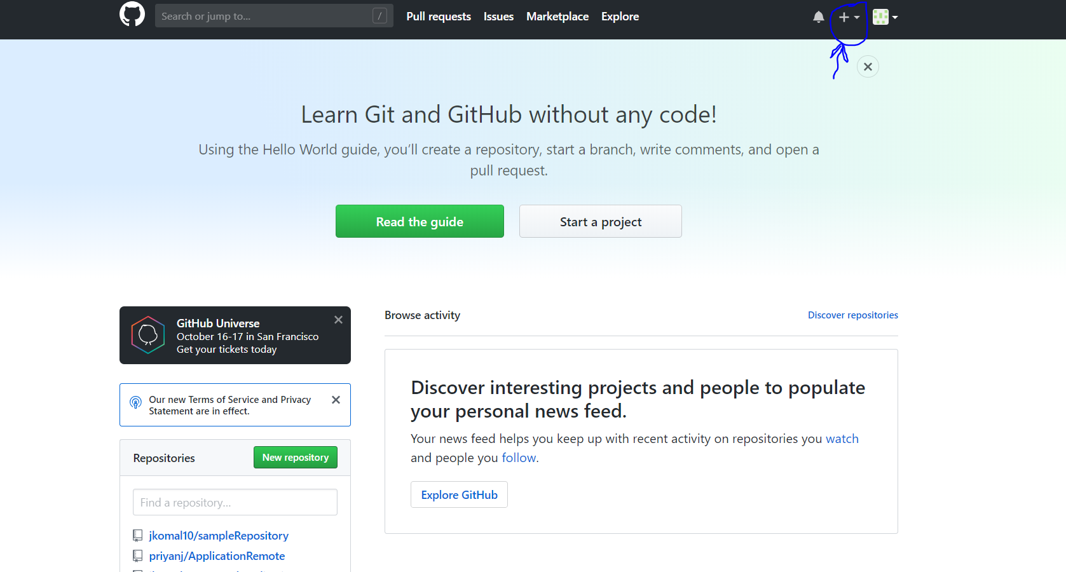

* 1. Then click on “New repository”

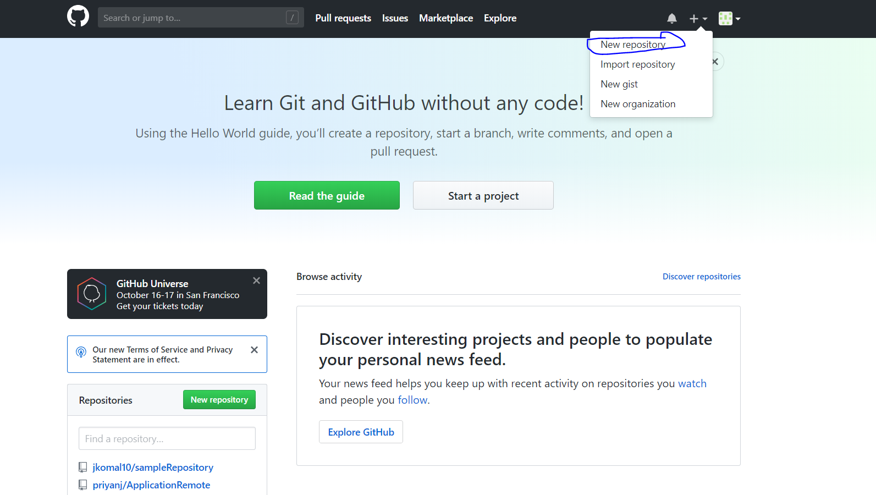

* 1. Enter Repository name , add description and then click on create repository.

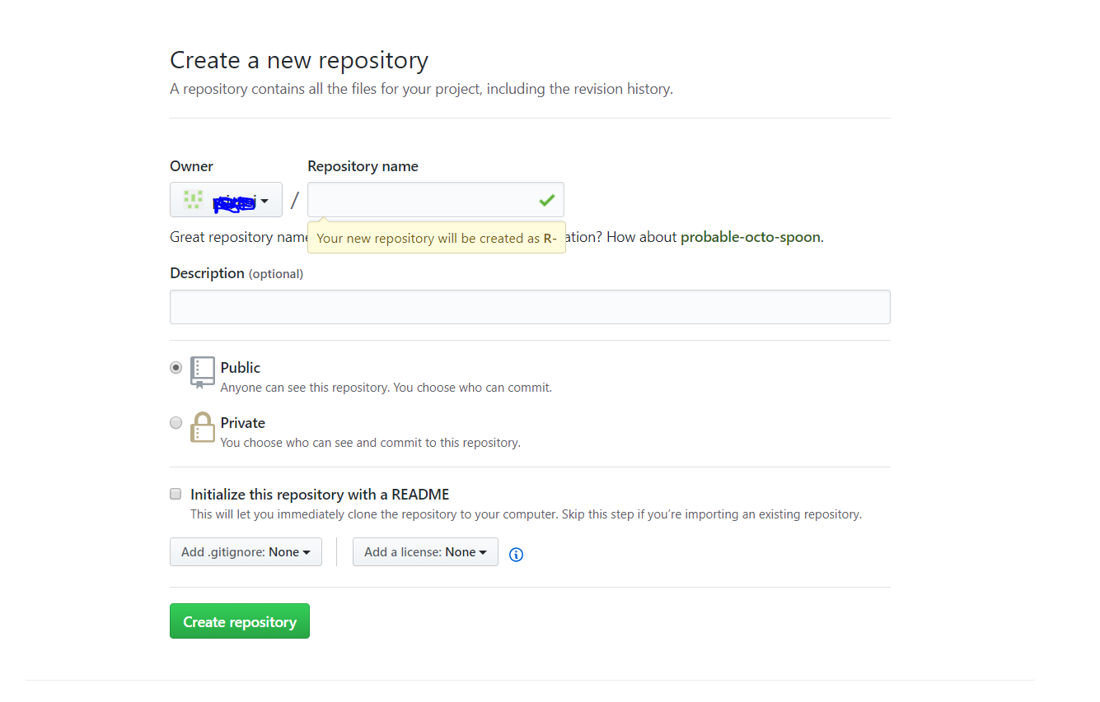

2.4 Copy url and keep it in secure place.

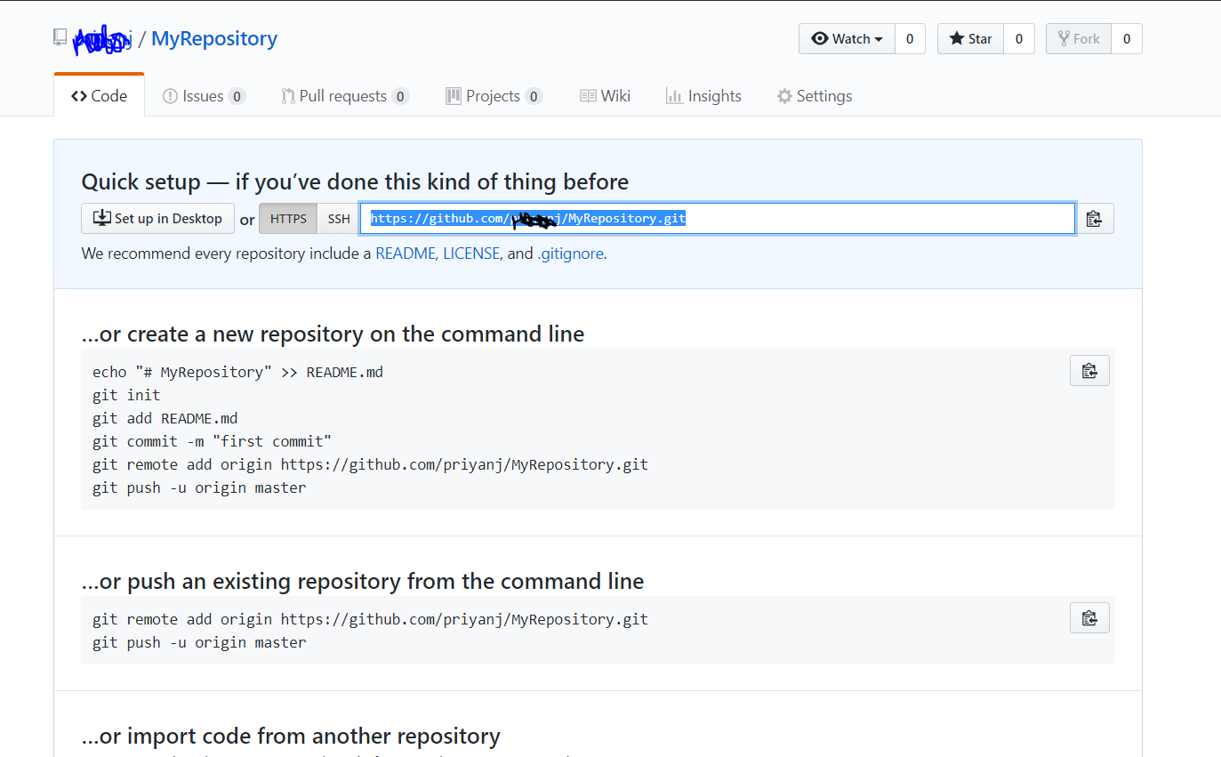

**Step-3: To Create local Repository**

**3.1** Create a new folder in any specific location. And right click and open gitbash(make sure you have installed gitbash)

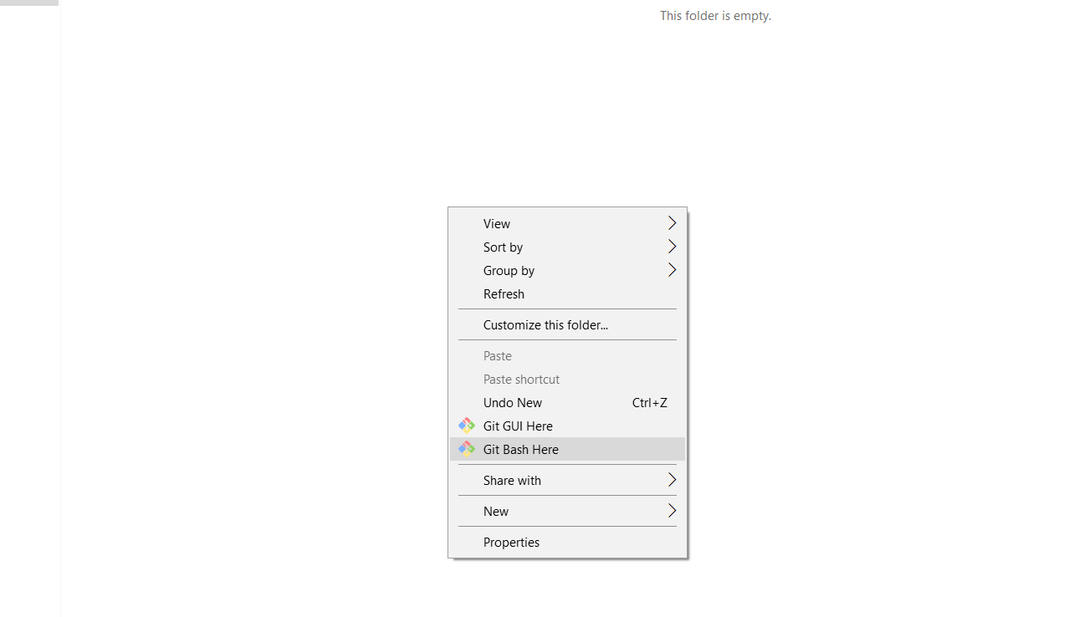

3.2 Clone your repository in local. Enter command git clone <copied url>

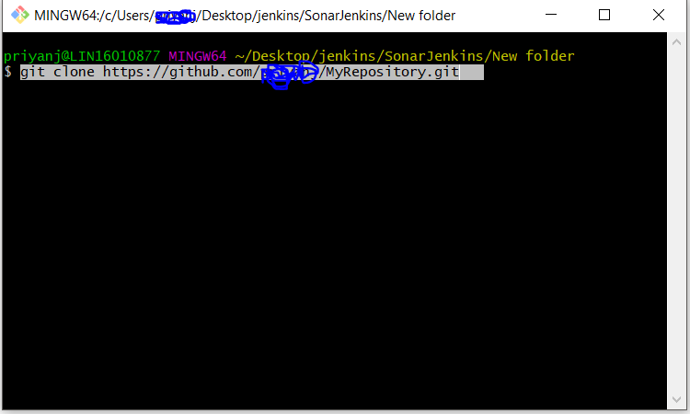

**Step-4 Add project into local repository**

4.1 Copy your project inside your repository folder where you have .git folder. Now you have added your project into local repository

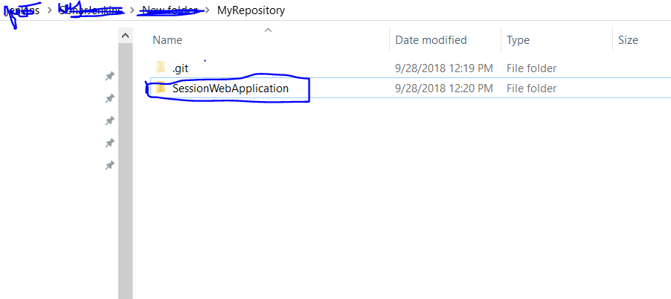

4.2 Open git bash here(make sure you should open “git bash” where you have .git folder)

And then type commands

git add .

git commit –m “any message”

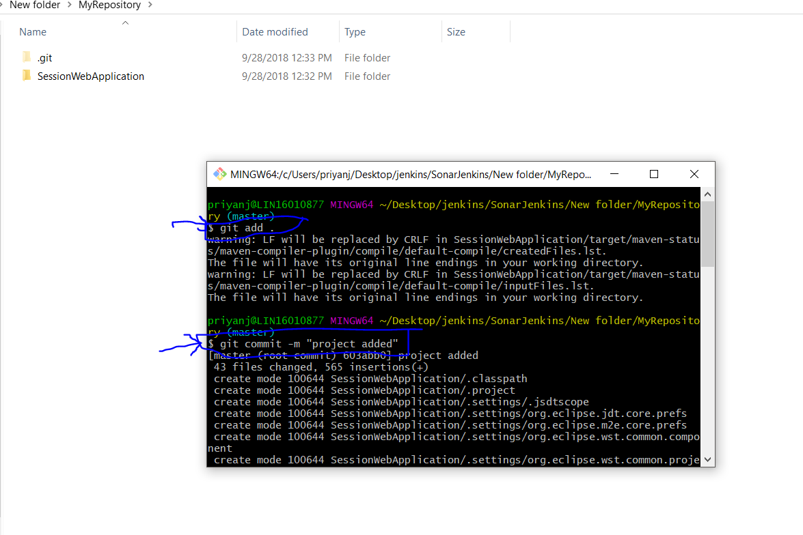

**Step-5: Add project into Remote repository.**

**5.1** Enter command git push and then your project will be add in remote repository.

git push

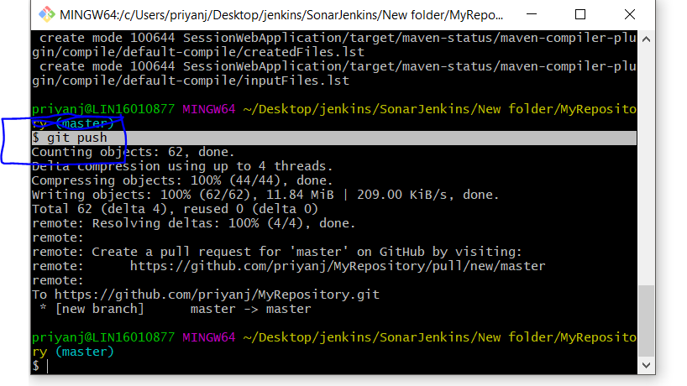

5.2 Now go to remote repository and check your project is in your remote repository.

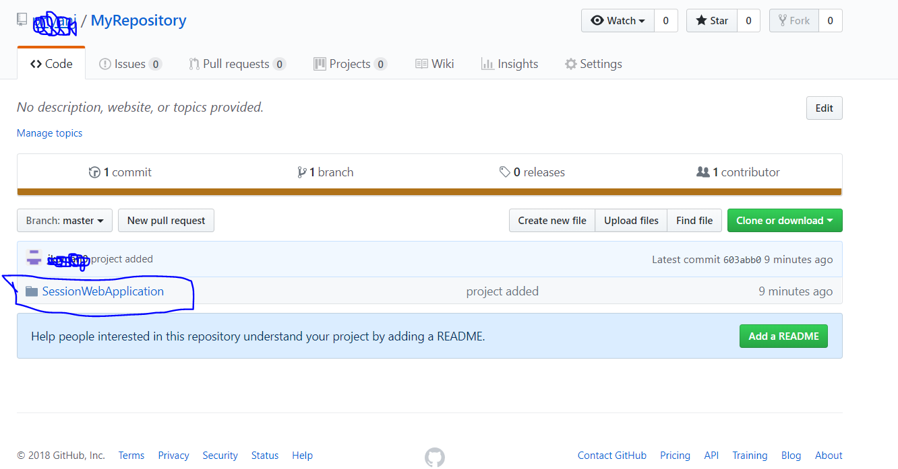

**Step 6 Get data from remote to local.(OPTIONAL)**

**5.1** Enter command git pull and then you will get all changes from remote to local repository.

git pull

